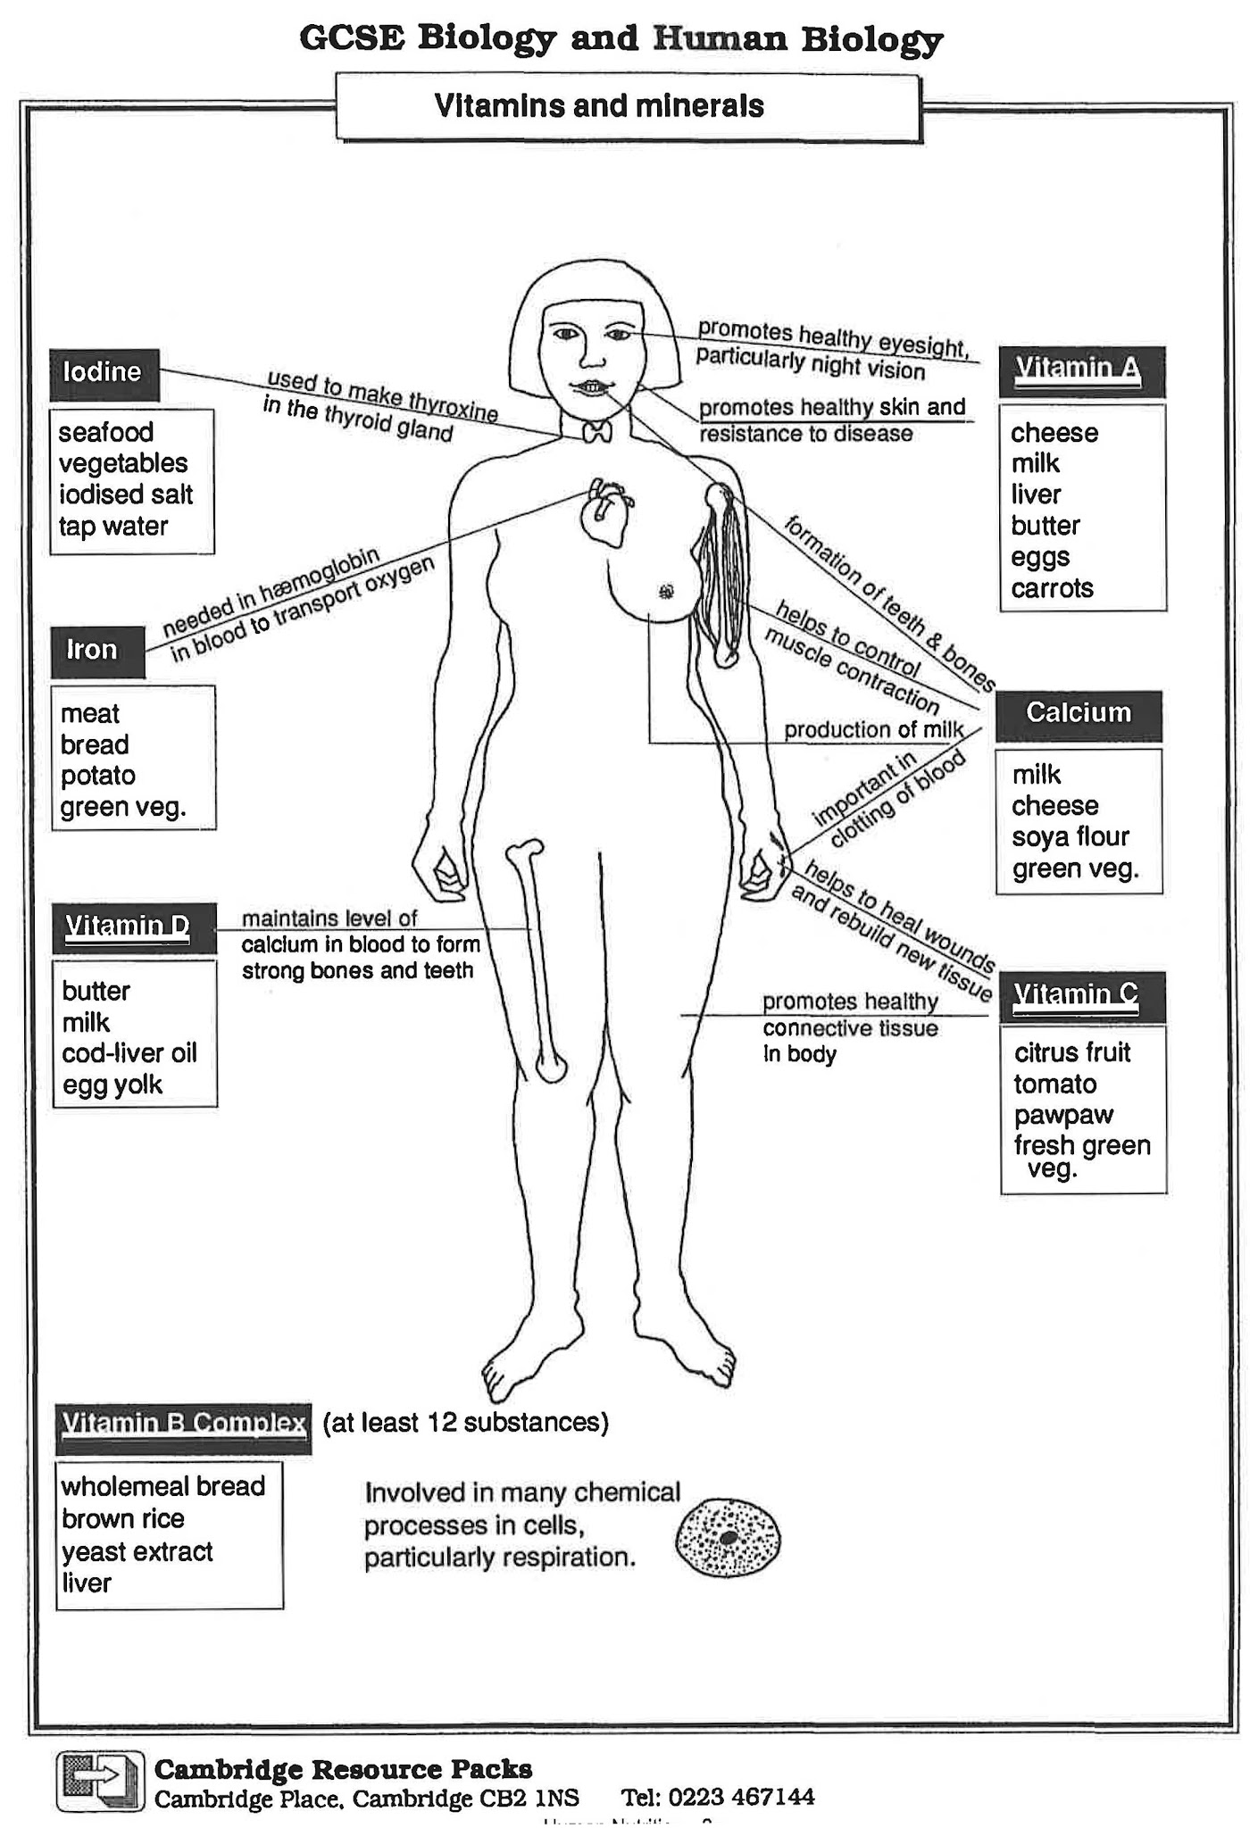
Vitamins and Minerals

- Rickets is a disease occurring in young children which makes the bones soft and deformed. Can you suggest which vitamin prevents rickets?

- If a person’s diet does not contain enough iron, he or she may become tired and pale. These are usually the first signs of iron-deficiency anaemia. What has happened in the body? Can you suggest what can be done to overcome it?

- Name one mineral and one vitamin in your diet which play important roles when you cut yourself. What do they each do?

- Why do people say that eating carrots helps you to see in the dark?

- Can you suggest why women need more calcium in their diets when they are pregnant and or lactating (producing milk)?

- Sailors on long voyages who had no fresh fruit or vegetables used to suffer from a disease called scurvy which causes swollen gums, bleeding under the skin, and wounds not healing. Can you suggest which substance prevents scurvy?

- Complete the following paragraph using the words provided below. Each word or phase may be used once, more than one or not at all.

Milk butter egg oranges green vegetables potatoes sea fish meat haemoglobin rickets obesity anaemia healing of wounds toothache scurvy night vision A C D iron iodine calcium deficiency

We need small quantities of certain minerals and vitamins in our daily diet to keep us healthy. Various ____ diseases may result of we do not obtain adequate amounts of these substances. Lack of Vitamin D causes ____ which affects the bones of young children. ____ may be caused by iron deficiency, as there is a shortage of ____ in the blood or transporting oxygen. Eating ____ helps to prevent simple goitre as it contains ____. ____ is important for many bodily functions, including formation of bones and teeth, and controls of muscle contraction. Vitamin C occurs in and promotes ____. Liver contains vitamin ____ which promotes ____ .

